ONE-PAGE EXTENDED ABSTRACT TITLE FOR EEECS 2025
(TIMES NEW ROMAN, 14 FONT SIZE, BOLD, ALL CAPS, CENTERED)

First A. Author*¹, Second B. Author² and Third C. Author³ (10 font size, Name and Surname)
^{1, 2}Affiliation, County
(E-mail: firstauthorsname@aaaa.bbb, secondauthorsname@aaaa.bbb)
² Affiliation, County
(E-mail: thirdauthorsname@aaaa.bbb)

ABSTRACT

Extended abstracts should be written according to underlying structure of the structured abstract and in a form that is shorter than the full text. Subtitles of the extended abstract should be composed from the sections of abstract and keywords, introduction and objective, method, findings and argument, conclusion and suggestions. Extended abstract of the full paper shall be written with Times New Roman font, single line spacing and 11 font size. Extended abstracts can contain figures, tables, formulations or images. Extended abstracts should be in a structure that explains the content of the declaration therefore the preparation phase of the said work. Page margins are formed regarding the A4 page size and are 2.5 cm wide from the right, left, top and bottom. End of the lines should be aligned to the righ and there shoul be no syllable segmentation. Extended abstracts should not exceed 2 pages including the references and pages should not be numbered.

Current literature regarding the work subject should be examined and the differences of the said work from the past, similar works should be presented clearly in the introduction section.

Keywords: Keywords regarding the work are stated in this section. Said section should contain maximum 5 words that are written with 10 font size and seperated with commas.

ACKNOWLEDGMENT
This work was supported by the National Research Foundation of Korea(NRF) grant funded by the Korean government(MSIP:Ministry of Science, ICT and Future Planning) (No. 123123)

REFERENCES
Resources that have been presented inside [ ] in the text with numbers should be listed according to their order in the text. References that have been presented in the references list should be prepared in a format according to the reference type shown below:

If the reference is an article;
- Pommiera, S., Chenub, D., Quintardb, M. ve Lefebvre, X., (2007). Modelling of moisture-dependent aerobic degradation of solid waste, Waste Management, 28, 7, 1188-1200
If the reference is a book;
- Li, G., Hart, A. ve Gregory, J., (1998). Flocculation and sedimentation, 295, Technomics Press, Lancaster PA.
If the reference is a chapter of a book;
- Blackburn, T., (1998). Flocculation and sedimentation in Li, G., Hart, A. ve Gregory, J., eds, Physical Processes, Technomics Press, 29-45, Lancaster PA.
If the reference is a declaration;
- Yıldız, Ş., Balahorli, V., (2009). Treatment of the waste water seepage with membrane systems: Istanbul example, Membrane Technologies and Implementation Symposium, Istanbul – Turkey.
If the reference is a Website;
- All 33 Chile miners freed in flawless rescue. (2010, October 13). Retrieved from http://www.msnbc.msn.com/id/39625809/ns/world_news-americas/.
TWO-PAGE EXTENDED ABSTRACT TITLE FOR EEECS 2025
(TIMES NEW ROMAN, 14 FONT SIZE, BOLD, ALL CAPS, CENTERED)

First A. Author*¹, Second B. Author² and Third C. Author³ (10 font size, Name and Surname)
^{1, 2}Affiliation, County
(E-mail: firstauthorsname@aaaa.bbb, secondauthorsname@aaaa.bbb)
² Affiliation, County
(E-mail: thirdauthorsname@aaaa.bbb)

ABSTRACT (11 Font Size, bold, all caps, centered)- Abstract should be written in 200 words and with 10 font size, Times New Roman, justified, single line spacing. Objective, method and findings are summarized in this section.

Keywords: Keywords regarding the work are stated in this section. Said section should contain maximum 5 words that are written with 10 font size and seperated with commas.

- INTRODUCTION (Title Times New Roman, 12 font size, bold, all caps)

Extended abstracts should be written according to underlying structure of the structured abstract and in a form that is shorter than the full text. Subtitles of the extended abstract should be composed from the sections of abstract and keywords, introduction and objective, method, findings and argument, conclusion and suggestions. Extended abstract of the full paper shall be written with Times New Roman font, single line spacing and 11 font size. Extended abstracts can contain figures, tables, formulations or images. Extended abstracts should be in a structure that explains the content of the declaration therefore the preparation phase of the said work. Page margins are formed regarding the A4 page size and are 2.5 cm wide from the right, left, top and bottom. End of the lines should be aligned to the righ and there shoul be no syllable segmentation. Extended abstracts should not exceed 2 pages including the references and pages should not be numbered.

Current literature regarding the work subject should be examined and the differences of the said work from the past, similar works should be presented clearly in the introduction section.

- TITLE (MATERIAL AND METHOD)

Equipment and method that have been used in the work must be stated clearly and subtitles should be used when necessary.

Results of the work and supporting figures, tables and images of the results should take part in the extended abstract. Not having appropriate content can cause disapproval of the sent declarations before judge’s assessment.

  - Subtitle

First degree titles (2.) should be written left aligned, all caps and bold. 2nd and 3rd degree subtitles (2.1-2.1.1) should be written left aligned, bold and with title case. A blank line should be placed between the paragraphs and there should not be any paragraph indentation.

    - Subtitle

All of the tables, images and figures should be centered. Figures and images should be numbered together (Figure 2) and figure definitions should be placed under the figure or image; as for the tables, they should also be numbered (Table 2) and the table header should be placed at the top of the chart. Table, image and figure headers should be written with upper case initial letters, bold and should be cebtered. References (if any) of the tables, figures and images should be presented just under the tables, figures and images in the form of author surname and publication date.

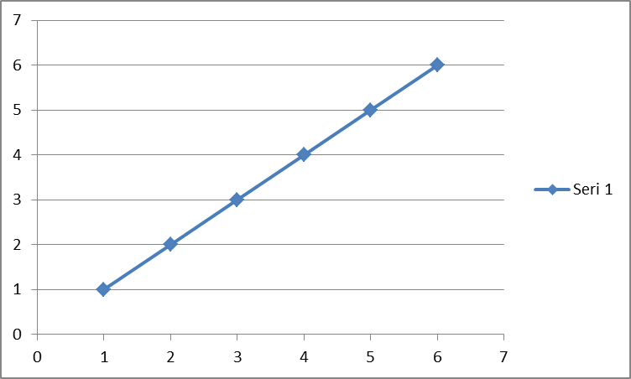

Figure 2. Figure Header

Table 2. Table Header
Reference: author surname and publication date

ACKNOWLEDGMENT

This work was supported by the National Research Foundation of Korea(NRF) grant funded by the Korean government(MSIP:Ministry of Science, ICT and Future Planning) (No. 123123)

REFERENCES

Resources that have been presented inside [ ] in the text with numbers should be listed according to their order in the text. References that have been presented in the references list should be prepared in a format according to the reference type shown below:

If the reference is an article;
- Pommiera, S., Chenub, D., Quintardb, M. ve Lefebvre, X., (2007). Modelling of moisture-dependent aerobic degradation of solid waste, Waste Management, 28, 7, 1188-1200
If the reference is a book;
- Li, G., Hart, A. ve Gregory, J., (1998). Flocculation and sedimentation, 295, Technomics Press, Lancaster PA.
If the reference is a chapter of a book;
- Blackburn, T., (1998). Flocculation and sedimentation in Li, G., Hart, A. ve Gregory, J., eds, Physical Processes, Technomics Press, 29-45, Lancaster PA.
If the reference is a declaration;
- Yıldız, Ş., Balahorli, V., (2009). Treatment of the waste water seepage with membrane systems: Istanbul example, Membrane Technologies and Implementation Symposium, Istanbul – Turkey.
If the reference is a Website;
- All 33 Chile miners freed in flawless rescue. (2010, October 13). Retrieved from http://www.msnbc.msn.com/id/39625809/ns/world_news-americas/.

